PRESS RELEASE

COMMUNICATIONS AND MEDIA TEAM OF THE 2023 ASEAN SUMMIT

No.30/SP/TKM-ASEAN2023/ENG/5/2023

Police Holds Operation Komodo 2023 to Secure the 42nd ASEAN Summit in Labuan Bajo

Jakarta, 5 Mei 2023 – The Indonesian National Police (Polri) is preparing a centralized operation codenamed "Komodo 2023" to ensure the security of the 42nd ASEAN Summit 2023, which will take place in Labuan Bajo, West Manggarai, East Nusa Tenggara (NTT) from 9 to 11 May.

This operation will be collaborated with other important aspects for succeeding the meeting of the heads of Southeast Asian countries.

"We are organizing a security mechanism that is detailed, integrated, and collaborative with all aspects, both security and supporting aspects of the Summit itself," said Operation Assistant to the National Police Chief, Inspector General. Pol. Agung Setya I. E. in a discussion at the Merdeka Barat 9 Forum (FMB9) entitled "Readiness for the 42nd ASEAN Summit 2023 Labuan Bajo" in Jakarta, Friday (5/5/2023).

Agung said, the National Police had prepared 2,627 personnel to work with the TNI and other stakeholders who had departed for Labuan Bajo since Thursday (5/5/2023). Officers immediately occupied security posts where the meeting took place and carried out routine training, especially to adjust to the conditions, topography, and uniqueness of Labuan Bajo.

"By managing this specific area, of course, an introduction to the location is needed. Then in more detail about what potentials we must manage and control so that security can be realized," he said.

He added that the National Police and the Military (TNI) had developed intense communication and cooperation. "The TNI has provided ships in the waters. Likewise, those on land. Then, friends from the Presidential Security Detail (Paspampres) have also arranged routes for the locations where the summit will take place," said the Inspector General. Pol. Agung.

For the security of the head of state, Paspampres will be assisted by 104 personnel from the police. The National Police have also provided a relatively long route from Labuan Bajo City to Golo Mori, one of the venues for the 42nd ASEAN Summit 2023.

"We have prepared a route that is quite long, approximately 36 km from Labuan Bajo City. We will prepare escorts so that the delegates arrive safely and smoothly at the location," he added.

Security is carried out in Labuan Bajo and the surrounding areas, especially Bali, because the planes of heads of state will be in Bali, and some will spend the nights on the Island of the Gods.

Prepare the Special and Anti-terror Task Forces

Polri has also provided eight task forces to anticipate disturbances and threats ahead of the 42nd ASEAN Summit in Labuan Bajo, including the Anti-terror Task Force.

"To anticipate the potential for real disturbances, we have prepared special task forces. We have eight task forces to handle this," explained Agung.

The Preventive Task Force from the Police Intelligence Agency, the State Intelligence Agency, and the TNI Strategic Intelligence Agency will handle potential disturbances.

Then there is also the Action and Anti-terror Task Force to ensure the readiness of the National Police if disturbances in the form of terror arise. There is also a Contingency Task Force for sudden health problems.

"We are also providing contingency measures. The National Police have prepared two helicopters; the TNI has prepared three helicopters and a ship hospital that has arrived in Labuan Bajo," explained Agung.

Agung said, in essence, the security for the ASEAN Summit in Labuan Bajo would be carried out with great care. The details will be adjusted to the uniqueness and beauty of nature and the people's hospitality.

"This is a dynamic we will continue to collaborate and integrate. We and the TNI always coordinate to keep up with the highly dynamic situations. For instance, schedule or activity changes that we must adapt to conditions and situations," he concluded.

FMB9 activities can also be followed directly on the FMB9ID_IKP YouTube channel. Wait for accurate information updates and valid data with trusted sources on FMB9ID_ (Twitter), FMB9.ID (Instagram), FMB9.ID (Facebook). (FMB 9/TR/Elvira/EL)***

For further information, please contact:
Director General of Public Information and Communications of the Ministry of Communications and Informatics – Usman Kansong (0816785320).

Get more information at http://asean2023.id, https://infopublik.id/kategori/asean-2023, dan https://indonesia.go.id/kategori/ragam-asean-2023

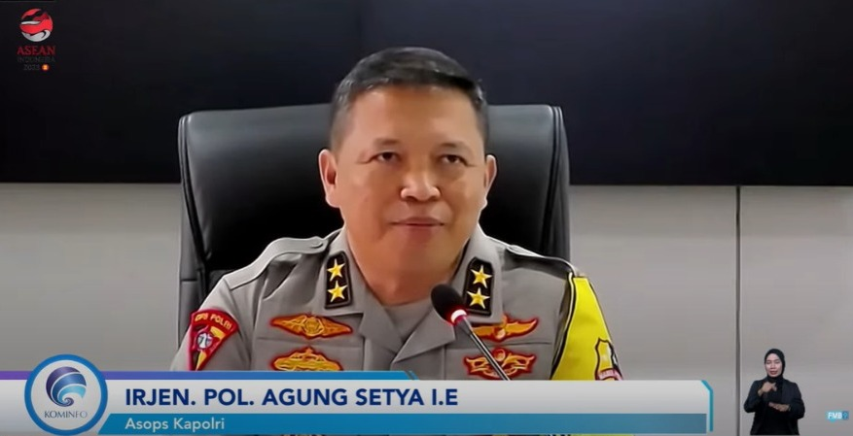

Operation Assistant to the National Police Chief, Inspector General. Pol. Agung Setya I. E. in a discussion at the Merdeka Barat 9 Forum (FMB9) entitled "Readiness for the 42nd ASEAN Summit 2023 Labuan Bajo" in Jakarta, Friday (5/5/2023). Polri is preparing a centralized operation codenamed "Komodo 2023" to ensure the security of the 42nd ASEAN Summit 2023.

